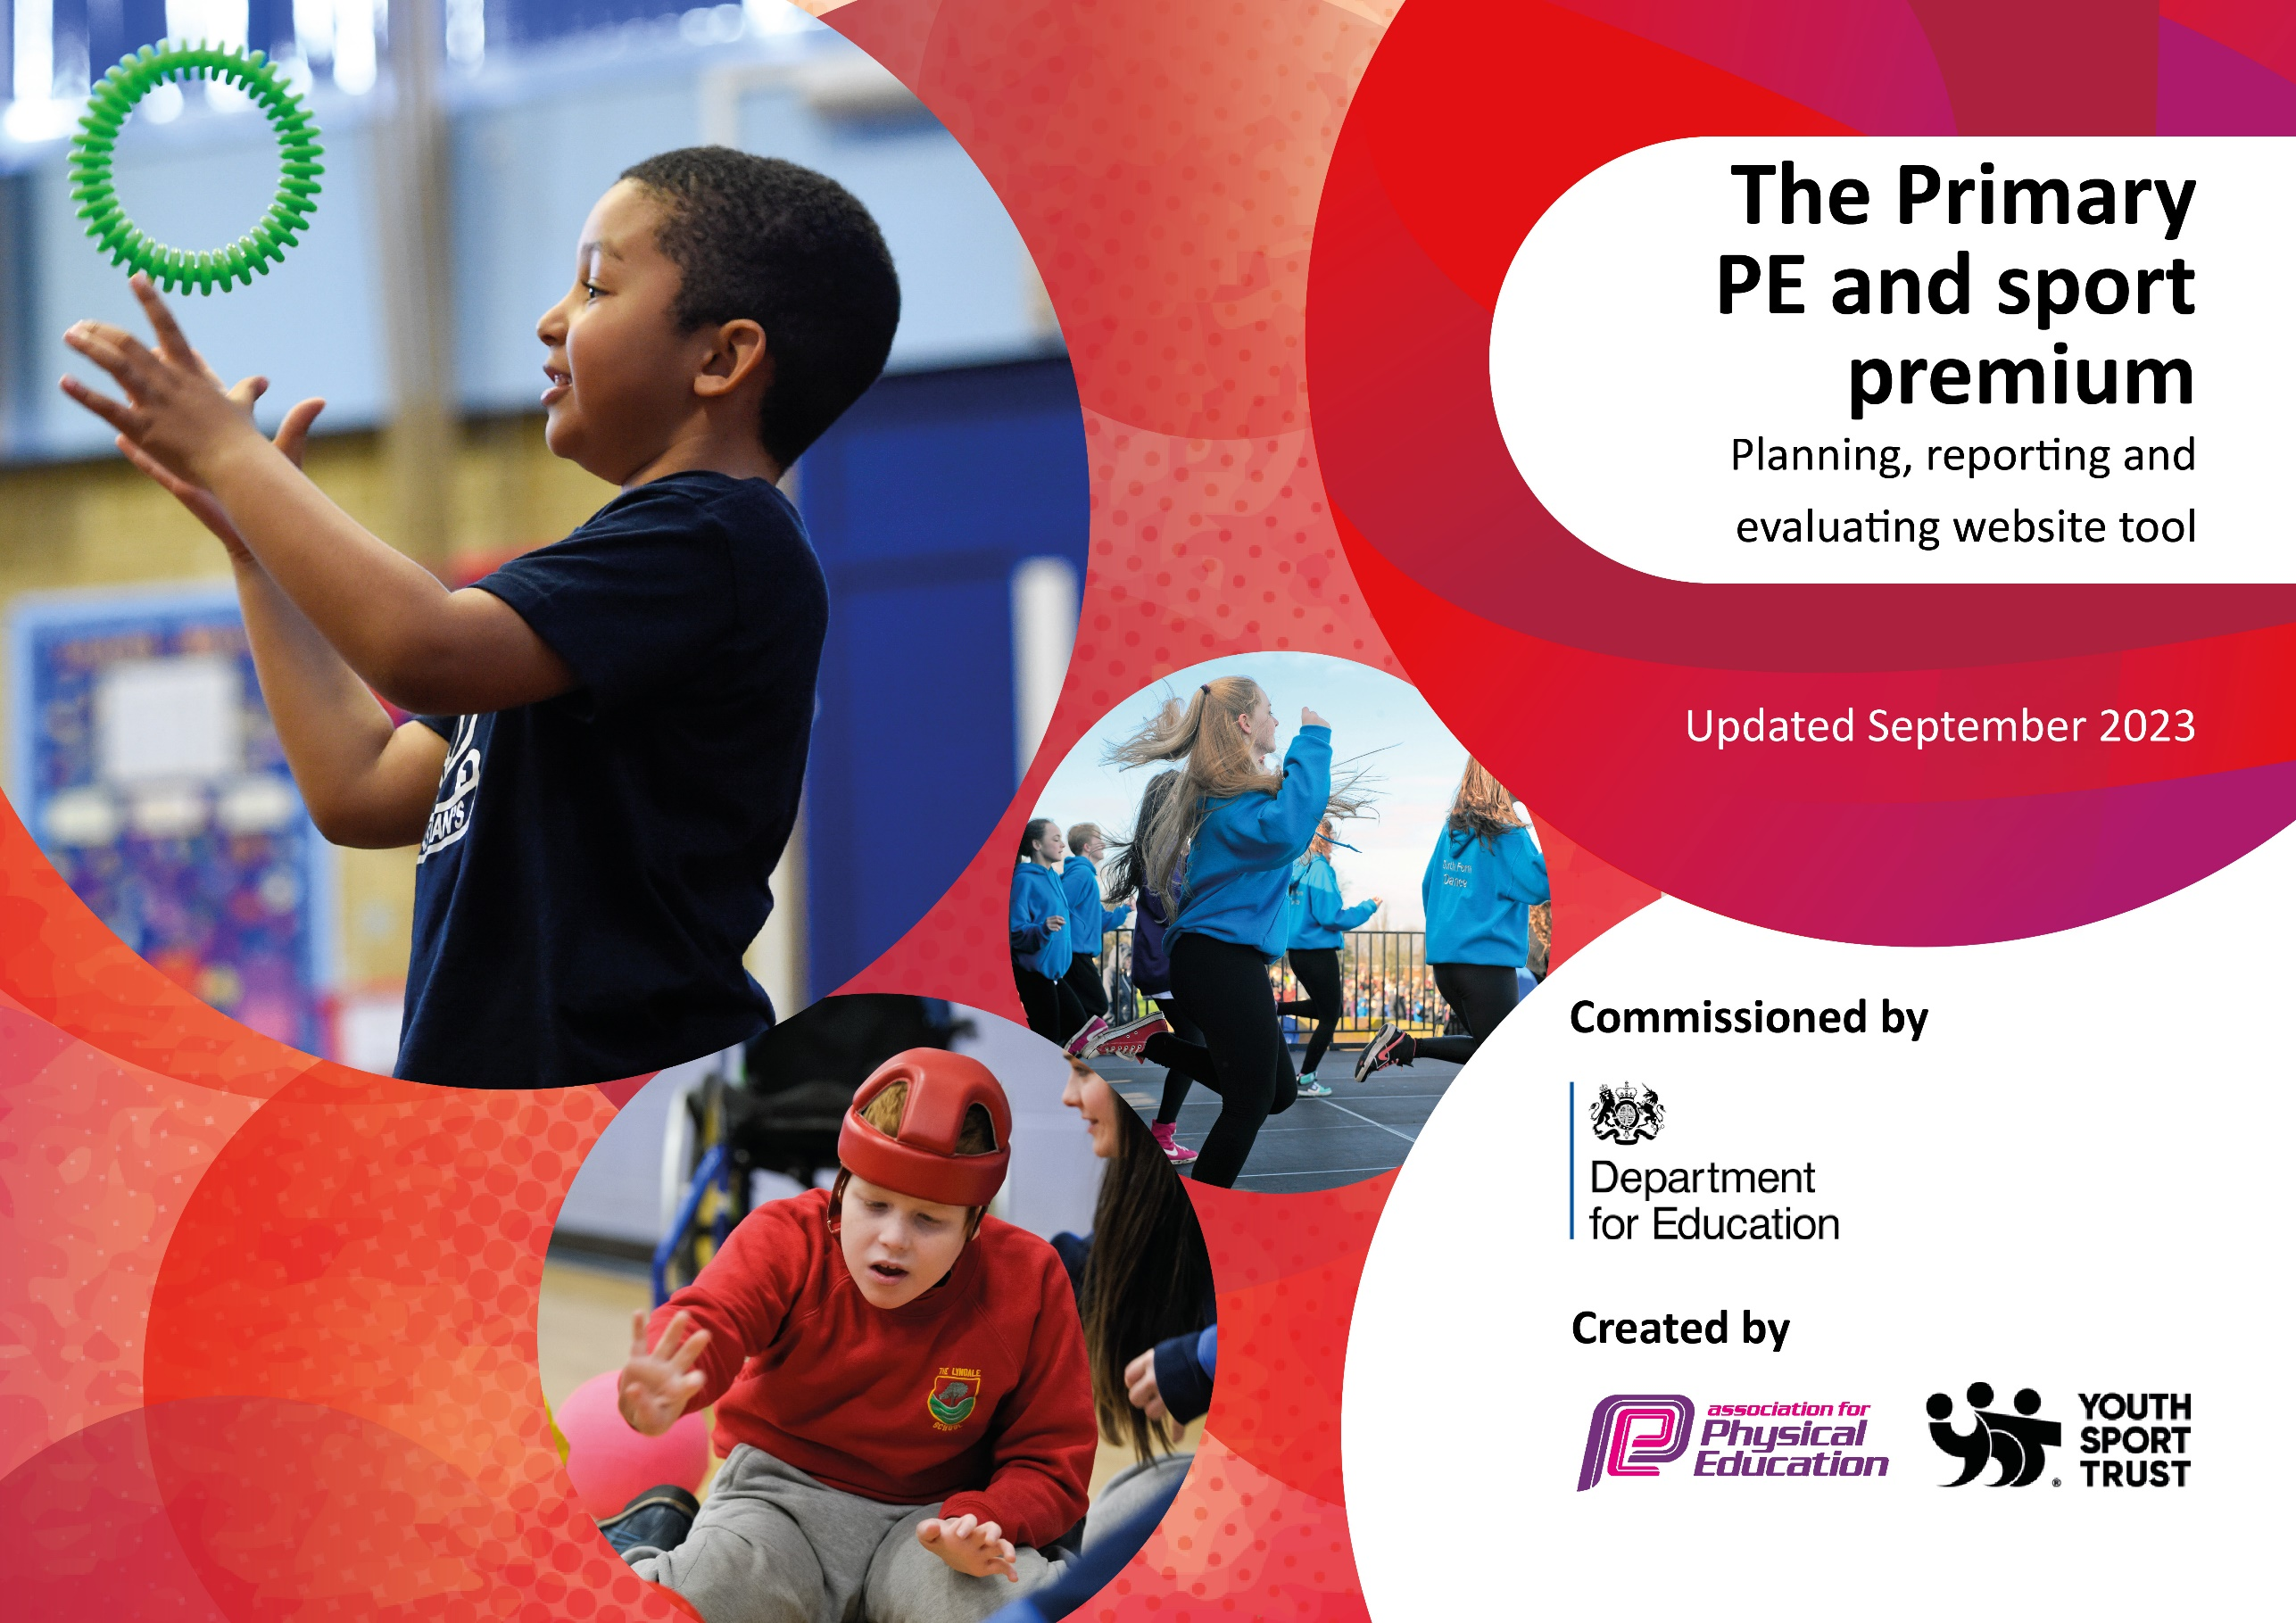

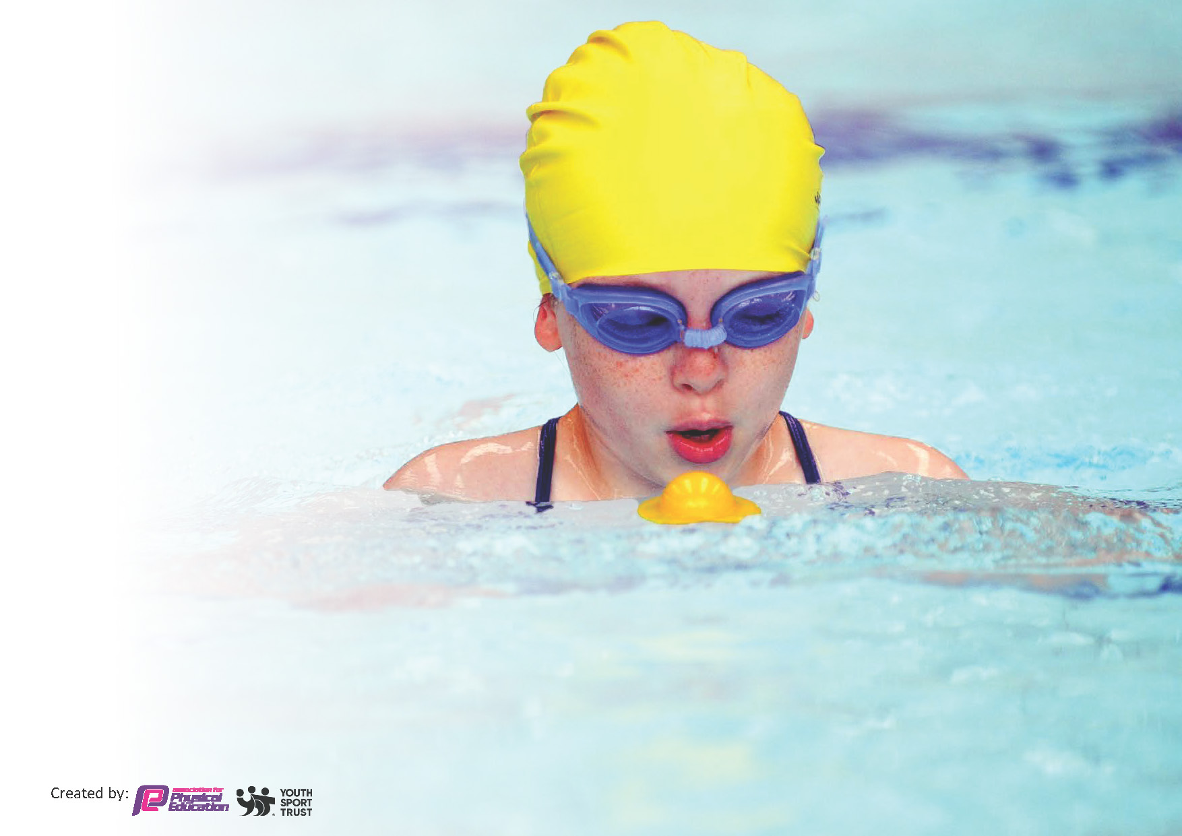
This template can be used for multiple purposes:
by:
- It enables schools to effectively plan their use of the Primary PE and sport premium
- It helps schools to meet the requirements (as set out in guidance) to publish information on their Primary PE and sport premium
- It will be an effective document to support Ofsted inspections enabling schools to evidence progress in Physical Education (PE) and evidence swimming attainment, which forms part of the PE National Curriculum. We would recommend schools consider
the Intent, Implementation and Impact of any spend, as examined within the Education Inspection Framework.

It is important that your grant is used effectively and based on school need.

Schools must use the funding to make additional and sustainable
improvements to the quality of the PE, School Sport and Physical Activity (PESSPA)
they offer. This means that you should use the Primary PE and sport premium to:

- Build capacity and capability within the school to ensure that improvements made now will benefit pupils joining the school in future years
- Develop or add to the PESSPA activities that your school already offers.

The Primary PE and sport premium should not be used to fund capital spend projects; the school’s core budget should fund these. Further detail on capital expenditure can be found in the updated Primary PE and sport premium guidance.

The Primary PE and sport premium guidance, outlines 5 key priorities that funding should be used towards. It is not

necessary that spending has to meet all the key priorities, you should select the priorities that you aim to use any funding towards.

Although completing this template is not a requirement for schools, schools are required to publish details of how they spend this funding. Schools must also outline what the impact this funding has had on pupils’ PE and sport participation and attainment and how any spending will be sustainable in the future. All funding must be spent by 31st July 2024.

The Department for Education has worked closely with the Association for Physical Education (afPE) and the Youth Sport Trust (YST) to develop this template and encourages schools to use it. This template is an effective way of meeting the reporting requirements of the Primary PE and sport premium.
Review of last year’s spend and key achievements (2022/2023)

We recommend you start by reflecting on the impact of current provision and reviewing your previous spend.

Activity/Action | Impact | Comments
- All children should have access to physical activity at regular intervals during the day, both at play time but also during lesson times. Children should have access to a variety of sports clubs led by specialists  - Year 6 children should have access to top up swimming in order to access NC swimming aims  - Invest in Kirby – children to access at lunchtimes and also in after-school clubs  - To develop teacher confidence in PE, ability to teach highquality PE in order to promote the importance of PE and sport to all children.  - House competitions Key Stage 2: opportunities to compete against other schools for a wide range of sporting activities. Children and parents should be provided with information regarding out-of-school sports club in the local and surrounding area, and staff should promote these clubs regularly to encourage children to take up a competitive sport out of school time | - 12 Playleaders in Y5 delivering daily sessions to KS1 children Lunchtime playground activities provided daily, all classes benefit.  - 2 activities per day – football and a second sport (over 80% of children accessing these activities) 90 children in KS1 had access to Playleader activities daily 20 children in KS2 have delivered lunchtime clubs to various year groups (dance, cheerleading, gymnastics, sports clubs)  - Approximately 75% of the school utilise Kidderminster Harriers and Sports Stars Education lunchtime activities  - Top Up swimming – 25 children in Y4/5/6 had access to weekly  - Teachers deliver 2nd weekly PE lesson to a high quality for all children Differentiation evident across curriculum  - Local sports clubs promoted on school newsletter throughout year Flyers handed out for various sports clubs Termly house competitions – 100% engagement

Key priorities and Planning
This planning template will allow schools to accurately plan their spending.

Action – what are you planning to do | Who does this action impact? | Key indicator to meet | Impacts and how sustainability will be achieved? | Cost linked to the action
CPD for Teaching Staff  Sports coaches to aid teacher confident and enhance learning experience for pupils. | - Teachers  - Pupils | 1,3 | Increased confidence, knowledge and skills of all staff in teaching PE that is of a highquality  Raised profile of the importance of PE and sport to all children. | £5985.00
To take part in a variety of sporting events across the year  Transport to venue (coaches) + staff | - Pupils | 1,2,3,4,5 | competitions (SSP and School Games). This has meant less disruption to core PE lessons/cover in school and greater opportunities for more pupils. HQPE is consistent whilst many pupils have benefited from participating in off-site physical activities. Coaches have enabled us to transport more pupils to the bigger events such as the Schools Games.  There is an increased number of pupils participating in festivals and competitions. This includes targeted groups (SEND, low self-esteem, G&T).  Pupils in school continue to enjoy the HQPE as there is no impact on the timetable/extra-curricular provision.  Sustainability: To continue to use PE specialist to organise and take pupils to these events and opportunities. | £1215.88
Top up Swimming  8 weeks of supply for cover | - Pupils | 1,4, | Pupils have participated in inspiring swimming lessons, using resources that have encouraged water confidence, stroke development and water safety knowledge.  Use of these swimming resources (equipment) has encouraged pupils to improve and develop quickly and confidently.  Sustainability: To safely store and look after equipment. Equipment is locked away when not in use. | £463  £1600
WFSSP – Wyre forest school sport partnership | Teachers  pupils | 1,2,3,4,5 | WFSSP provides significant support and opportunities for all pupils. The number and range of festivals and competitions has impacted on many of our pupils, providing them experiences that will contribute to them leading healthy and active lifestyles. See calendars for all opportunities  By sharing good practice through our network, HQ PE is delivered confidently and effectively.  PE staff are up to date with CPD and initiatives, resulting in positive experiences for all pupils.  Pupils have access to a calendar of festivals and events.  More pupils take on leadership/volunteering roles.  The PE curriculum is more creative – this is because of sharing good practice with other schools and introducing new sports/activities.  Sustainability - continued commitment to the partnership will ensure all our pupils have opportunities to compete/participate in a range of sports and physical activities. | £2302
Harriers | Pupils | 1,2,3,5, | To provide extra curricular physical activity at lunch times and after school  Children have professional training and aid to help stimulate motivation in sport. | £4800
Our lady Queen of peace- catholic schools Worcestershire | Pupils | 3,4 | To promote a sense of community and togetherness and widening our participation with local schools. | £150
Coordinator time – supply cover | Teacher | 1 | Attending the 3 P.E CPD sessions connecting with other leader receiving and sharing ideas.  Also, long term plan was designed to target areas of improvement in the curriculum to allow for more inclusion. | £1125

Key achievements 2023-2024
This template will be completed at the end of the academic year and will showcase the key achievements schools have made with their Primary PE and sport premium spending.

Activity/Action | Impact | Comments
Top up Swimming – improved outcomes for swimming – 86%  To take part in a variety of sporting events across the year  CPD for Teaching Staff  Sports coaches to aid teacher confident and enhance learning experience for pupils. | Pupils have participated in inspiring swimming lessons, using resources that have encouraged water confidence, stroke development and water safety knowledge.  Use of these swimming resources (equipment) has encouraged pupils to improve and develop quickly and confidently.  There is an increased number of pupils participating in festivals and competitions. This includes targeted groups (SEND, low self-esteem, G&T).  Pupils in school continue to enjoy the HQPE as there is no impact on the timetable/extra-curricular provision.  Increased confidence, knowledge and skills of all staff in teaching PE that is of a highquality  Raised profile of the importance of PE and sport to all children | This year, sport premium funding has enhanced the experiences of pupils. It has been accessible to a wider range of pupils such as SEN (bowling sessions) and pupil premium specific.  The CPD for teachers has furthered staff knowledge and enhanced confidence to teach high quality P.E.

Swimming Data
Meeting National Curriculum requirements for swimming and water safety.
Priority should always be given to ensuring that pupils can perform safe self-rescue even if they do not fully meet the first two requirements of the National Curriculum programme of study

Question | Stats: | Further context  Relative to local challenges
What percentage of your current Year 6 cohort can swim competently, confidently and proficiently over a distance of at least 25 metres? | 89% | Children have attended curriculum and top up swimming lessons since year 4. Some attend private swimming lessons outside of school.  Our school swim weekly at a local pool that is walking distance away.  2 children did not wish to take part in top up swimming which may have effected the result.
What percentage of your current Year 6 cohort can use a range of strokes effectively [for example, front crawl, backstroke, and breaststroke]? | 89% | Most of the year 6 cohort can use a range of different strokes depending on what the teaching is asking. Children have been taught a variety of strokes and have built up good techniques to execute the strokes effectively.

What percentage of your current Year 6 cohort are able to perform safe self-rescue in different water-based situations? | 100% | Children has used sculling techniques as well as using floats and buoyancy aids to help them practice a safe self- rescue technique.
If your schools swimming data is below national expectation, you can choose to use the Primary PE and sport premium to provide additional top-up sessions for those pupils that did not meet National Curriculum  requirements after the completion of core lessons. Have you done this? | Yes | Children not achieving 25 meters were given an extra term of swimming to help achieve more confident and stronger swimming.
Have you provided CPD to improve the knowledge and confidence of staff to be able to teach swimming and water safety? | Yes | 2 staff members have level 3 swimming teacher qualifications funded by sports premium previously.

Signed off by:

Head Teacher: | E.Brocklesby
Subject Leader or the individual responsible for the Primary PE and sport premium: | G.Noble
Governor: | D.Gillett
Date: | 31.07.2024

